Terraform Task-6
1. Execute the script shown in the video

Terraform Modules
A Terraform module is a reusable collection of Terraform configuration files that can be used to create and manage infrastructure.

1. Why do we need modules?
Imagine you need to create an EC2 server.
Without a module, you might have:
project/
├── main.tf
├── variables.tf
└── outputs.tf
And your main.tf contains all the EC2, security group, IAM, etc.
Now suppose you need:
Development EC2
Production EC2
Testing EC2
You could duplicate the same Terraform code three times.
That's not a good approach.
With modules:
Root Module
│
├── EC2 Module → Development
│
├── EC2 Module → Production
│
└── EC2 Module → Testing
You write the infrastructure logic once and reuse it.
Example:
Creating one EC2 instance
Write terraform code in main.tf
And maintain the variable.tf for calling variables
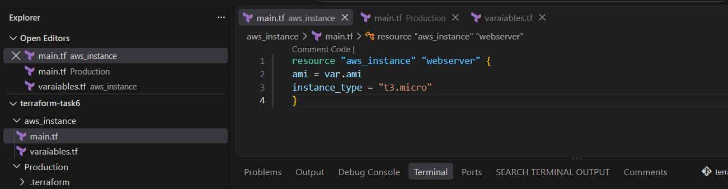
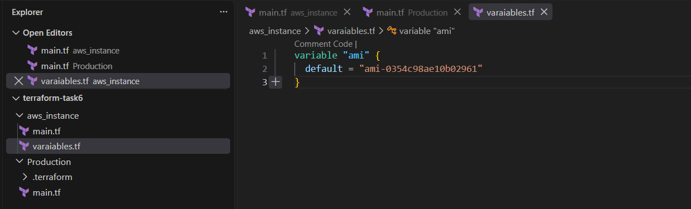
Goto to the production environment and write terraform code in main.tf which consist of Module block.
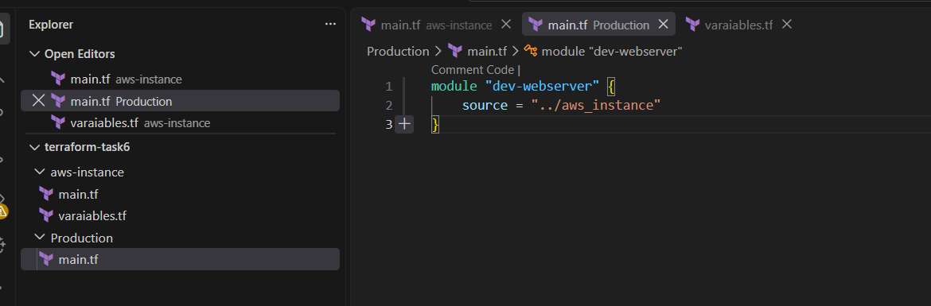
On terminal goto production location and run terraform
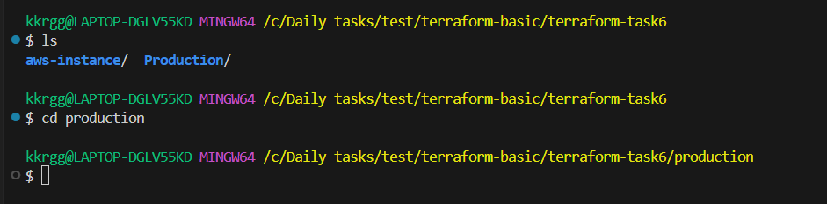
Terraform init
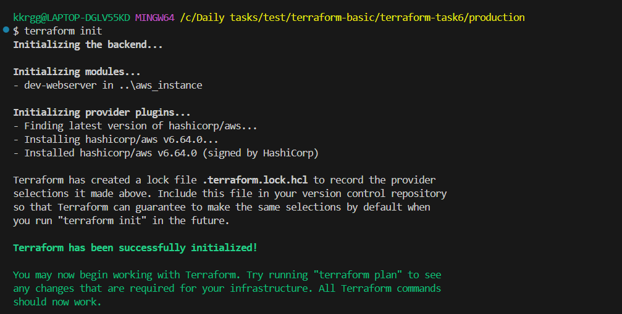

Terraform validate
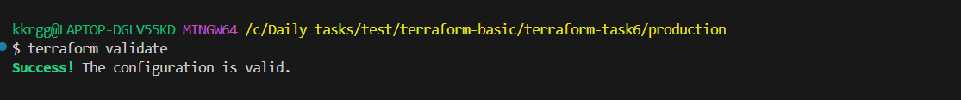
Terraform plan
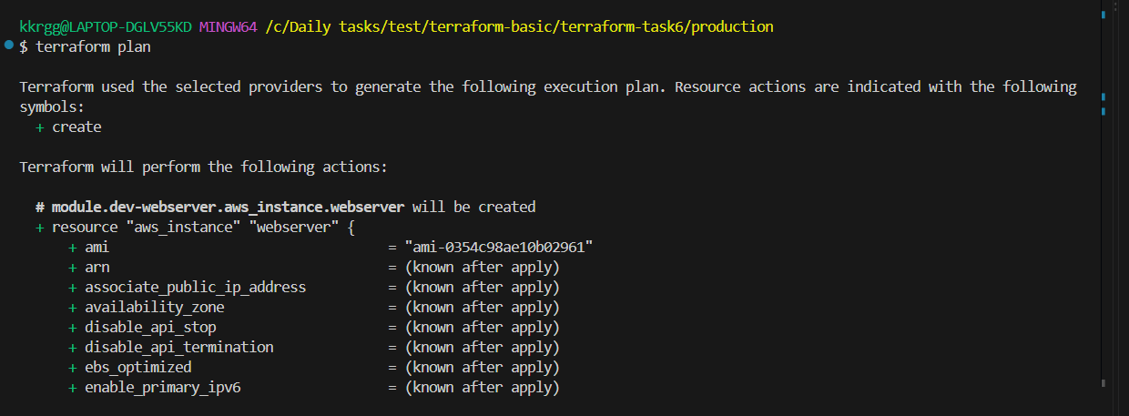
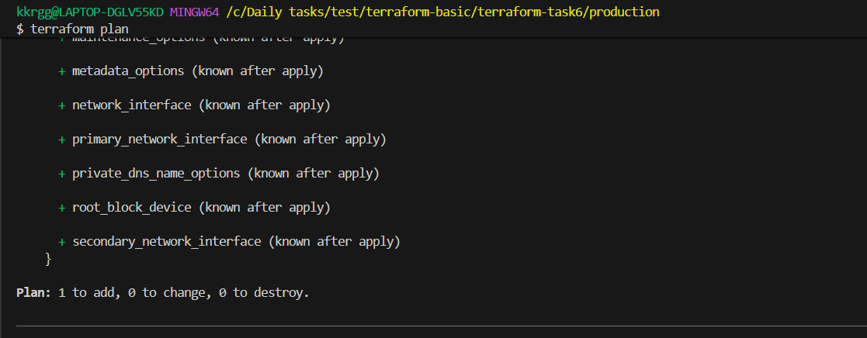

Terraform apply
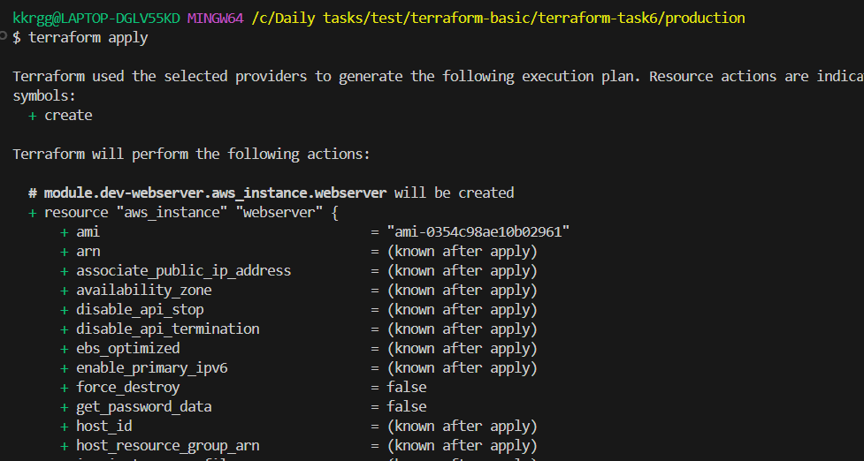
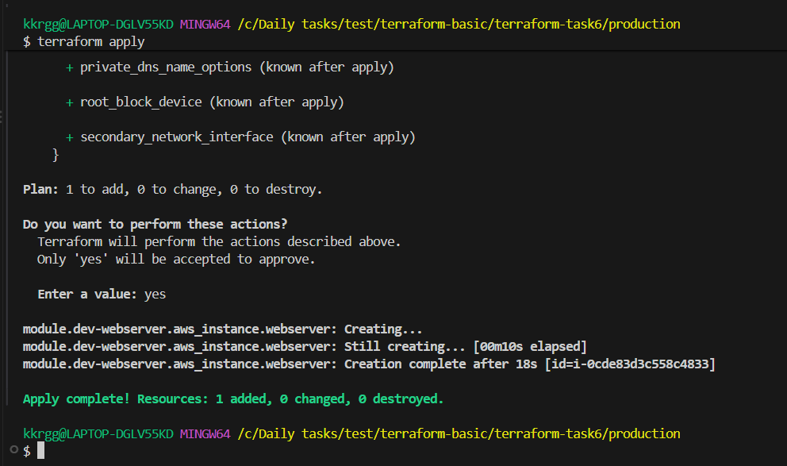
Goto AWS console and check instances
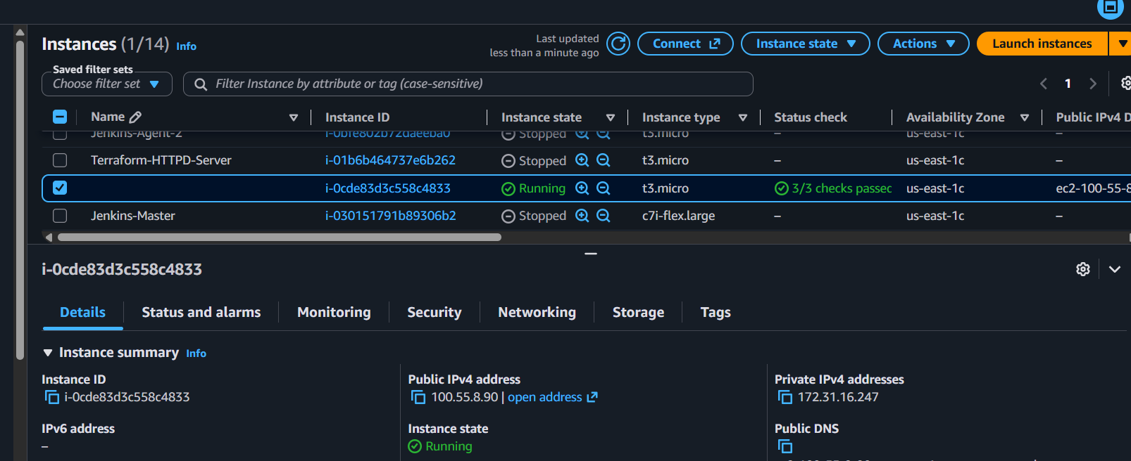

Terraform Workspaces
A Terraform workspace allows you to use the same Terraform configuration/code to manage different environments with separate state files.

Example
Suppose you have:
Terraform Code
│
├── dev workspace → Development infrastructure
├── test workspace → Testing infrastructure
└── prod workspace → Production infrastructure
The code can be the same, but each workspace has its own state.
For example:
terraform.tfstate.d/
├── dev/
│ └── terraform.tfstate
├── test/
│ └── terraform.tfstate
└── prod/
└── terraform.tfstate
So if you create an EC2 instance in the dev workspace, Terraform tracks it separately from the EC2 instance in prod.

Basic commands

Check current workspace
terraform workspace show

List workspaces
terraform workspace list

Create a workspace
terraform workspace new workspacename

Switch workspace
terraform workspace select workspacename

Delete a workspace
terraform workspace delete workspacename
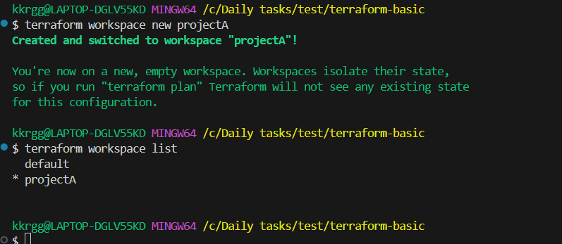
Example
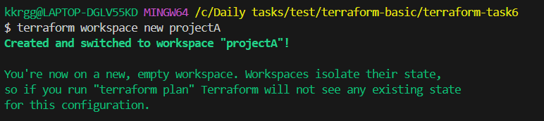
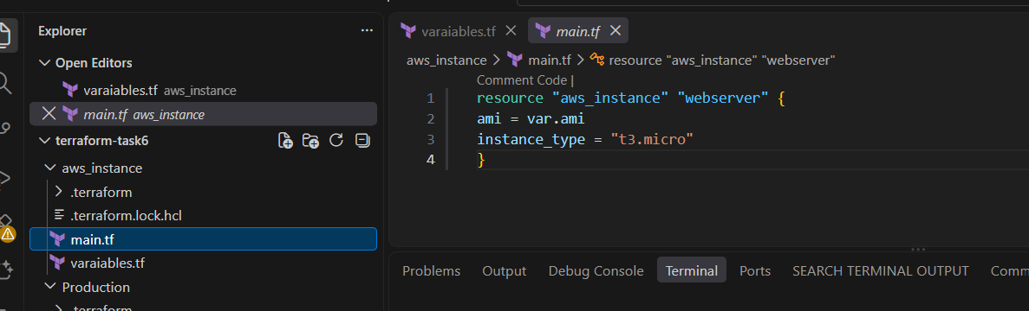
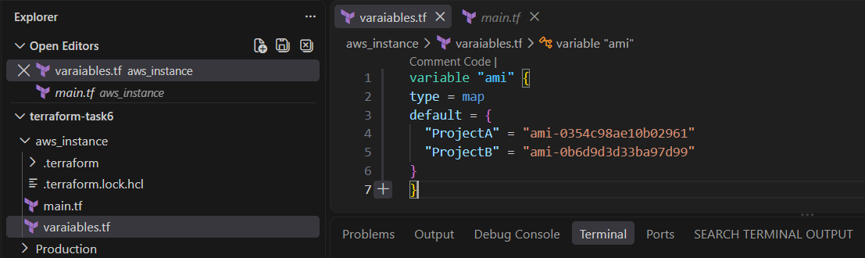
Run terraform
Terraform init
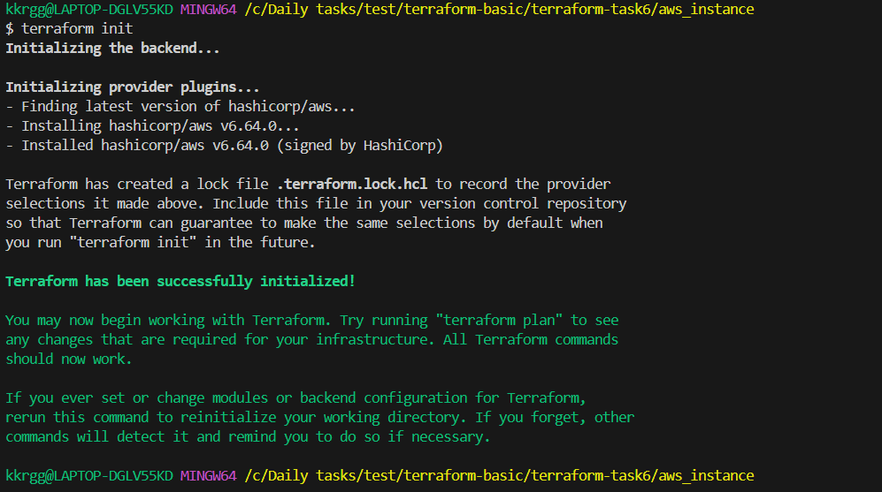
Terraform apply

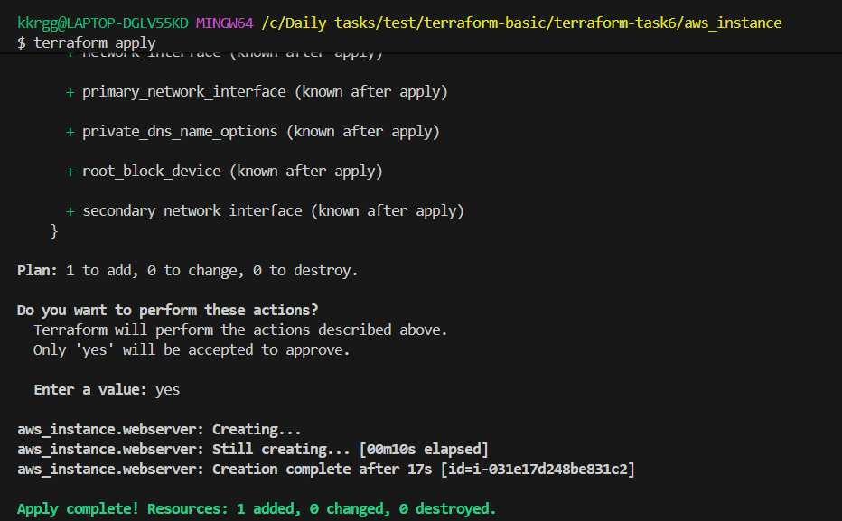
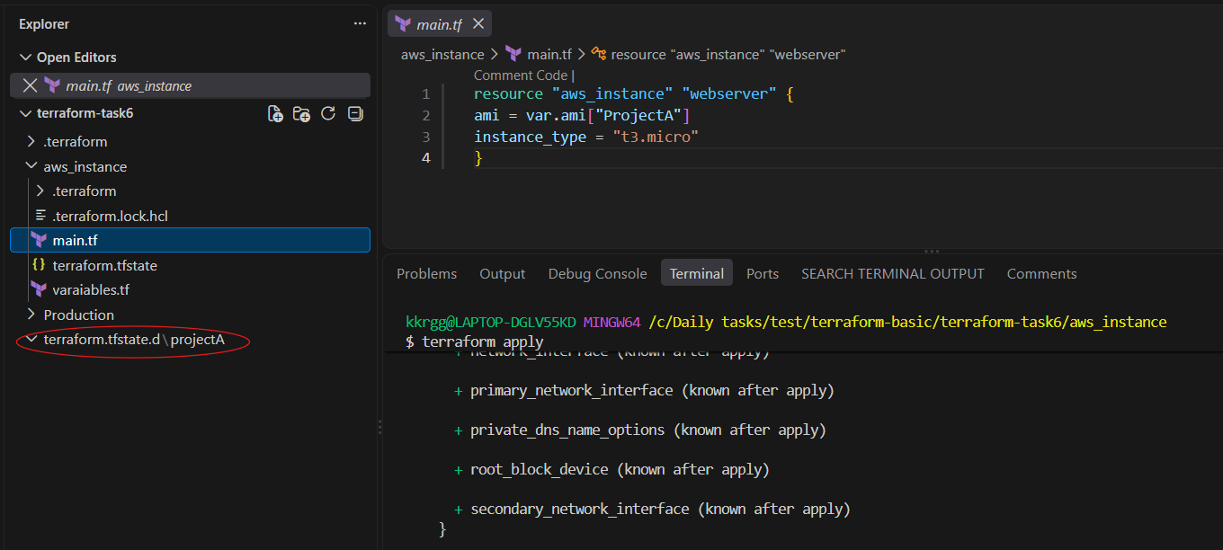

2. Provision EC2, S3, and VPC using Terraform modules.

Objective
Create AWS infrastructure using reusable Terraform modules:
Terraform Root Module
│
├── VPC Module
│ ├── VPC
│ ├── Public Subnet
│ └── Internet Gateway
│
├── EC2 Module
│ ├── Security Group
│ └── EC2 Instance
│
└── S3 Module
└── S3 Bucket

Expected outcome
After terraform apply, we should have:
- 1 VPC
- 1 Public Subnet
- 1 Internet Gateway
- 1 Security Group
- 1 EC2 instance
- 1 S3 bucket
We'll use us-east-1.

1. Create the project structure
Create a directory:
mkdir terraform-modules-task
cd terraform-modules-task
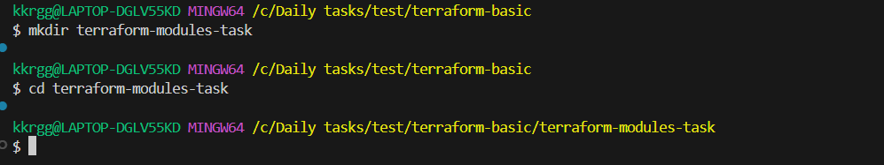

Create this structure:
terraform-modules-task/
│
├── main.tf
├── variables.tf
├── outputs.tf
├── terraform.tfvars
│
└── modules/
│
├── vpc/
│ ├── main.tf
│ ├── variables.tf
│ └── outputs.tf
│
├── ec2/
│ ├── main.tf
│ ├── variables.tf
│ └── outputs.tf
│
└── s3/
├── main.tf
├── variables.tf
└── outputs.tf

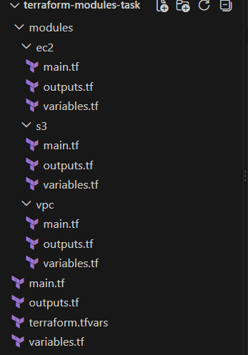

2. Create the VPC module

2.1 modules/vpc/main.tf
resource "aws_vpc" "main" {
cidr_block = var.vpc_cidr

tags = {
Name = var.vpc_name
}
}

resource "aws_subnet" "public" {
vpc_id = aws_vpc.main.id
cidr_block = var.public_subnet_cidr
availability_zone = var.availability_zone
map_public_ip_on_launch = true

tags = {
Name = "${var.vpc_name}-public-subnet"
}
}

resource "aws_internet_gateway" "main" {
vpc_id = aws_vpc.main.id

tags = {
Name = "${var.vpc_name}-igw"
}
}

resource "aws_route_table" "public" {
vpc_id = aws_vpc.main.id

route {
cidr_block = "0.0.0.0/0"
gateway_id = aws_internet_gateway.main.id
}

tags = {
Name = "${var.vpc_name}-public-rt"
}
}

resource "aws_route_table_association" "public" {
subnet_id = aws_subnet.public.id
route_table_id = aws_route_table.public.id
}

2.2 modules/vpc/variables.tf
variable "vpc_cidr" {
type = string
}

variable "public_subnet_cidr" {
type = string
}

variable "availability_zone" {
type = string
}

variable "vpc_name" {
type = string
}

2.3 modules/vpc/outputs.tf
output "vpc_id" {
value = aws_vpc.main.id
}

output "public_subnet_id" {
value = aws_subnet.public.id
}
The important point here is that the VPC module returns the VPC ID and subnet ID to the root module.

3. Create the EC2 module

3.1 modules/ec2/main.tf
resource "aws_security_group" "ec2" {
name = "${var.instance_name}-sg"
description = "Security group for EC2 instance"
vpc_id = var.vpc_id

ingress {
description = "SSH"
from_port = 22
to_port = 22
protocol = "tcp"
cidr_blocks = ["0.0.0.0/0"]
}

egress {
from_port = 0
to_port = 0
protocol = "-1"
cidr_blocks = ["0.0.0.0/0"]
}

tags = {
Name = "${var.instance_name}-sg"
}
}

resource "aws_instance" "ec2" {
ami = var.ami_id
instance_type = var.instance_type
subnet_id = var.subnet_id
vpc_security_group_ids = [aws_security_group.ec2.id]
associate_public_ip_address = true

tags = {
Name = var.instance_name
}
}

3.2 modules/ec2/variables.tf
variable "ami_id" {
type = string
}

variable "instance_type" {
type = string
}

variable "subnet_id" {
type = string
}

variable "vpc_id" {
type = string
}

variable "instance_name" {
type = string
}

3.3 modules/ec2/outputs.tf
output "instance_id" {
value = aws_instance.ec2.id
}

output "public_ip" {
value = aws_instance.ec2.public_ip
}

output "security_group_id" {
value = aws_security_group.ec2.id
}

4. Create the S3 module

4.1 modules/s3/main.tf
resource "aws_s3_bucket" "bucket" {
bucket = var.bucket_name

tags = {
Name = var.bucket_name
}
}

4.2 modules/s3/variables.tf
variable "bucket_name" {
type = string
}

4.3 modules/s3/outputs.tf
output "bucket_name" {
value = aws_s3_bucket.bucket.bucket
}

output "bucket_arn" {
value = aws_s3_bucket.bucket.arn
}

5. Root main.tf
Now we call the three modules.
Create:
main.tf
with:
terraform {
required_providers {
aws = {
source = "hashicorp/aws"
version = "~> 6.0"
}
}
}

provider "aws" {
region = var.aws_region
}

module "vpc" {
source = "./modules/vpc"

vpc_cidr = var.vpc_cidr
public_subnet_cidr = var.public_subnet_cidr
availability_zone = var.availability_zone
vpc_name = var.vpc_name
}

module "ec2" {
source = "./modules/ec2"

ami_id = var.ami_id
instance_type = var.instance_type
subnet_id = module.vpc.public_subnet_id
vpc_id = module.vpc.vpc_id
instance_name = var.instance_name
}

module "s3" {
source = "./modules/s3"

bucket_name = var.bucket_name
}

Important part
Notice:
subnet_id = module.vpc.public_subnet_id
and:
vpc_id = module.vpc.vpc_id
This is how the EC2 module receives outputs from the VPC module.

6. Root variables.tf
Create:
variable "aws_region" {
type = string
}

variable "vpc_cidr" {
type = string
}

variable "public_subnet_cidr" {
type = string
}

variable "availability_zone" {
type = string
}

variable "vpc_name" {
type = string
}

variable "ami_id" {
type = string
}

variable "instance_type" {
type = string
}

variable "instance_name" {
type = string
}

variable "bucket_name" {
type = string
}

7. Root terraform.tfvars
Since you want us-east-1, use:
aws_region = "us-east-1"

vpc_cidr = "10.0.0.0/16"

public_subnet_cidr = "10.0.1.0/24"

availability_zone = "us-east-1a"

vpc_name = "terraform-module-vpc"

ami_id = "ami-xxxxxxxxxxxxxxxxx"

instance_type = "t3.micro"

instance_name = "terraform-module-ec2"

bucket_name = "terraform-modules-0549-demo"

Important
Replace:
ami-xxxxxxxxxxxxxxxxx
with a valid Amazon Linux AMI ID for us-east-1 available in your account.
Also, S3 bucket names must be globally unique. If:
terraform-modules-0549-demo
already exists, change it to something unique.

8. Root outputs.tf
Create:
output "vpc_id" {
value = module.vpc.vpc_id
}

output "public_subnet_id" {
value = module.vpc.public_subnet_id
}

output "ec2_instance_id" {
value = module.ec2.instance_id
}

output "ec2_public_ip" {
value = module.ec2.public_ip
}

output "security_group_id" {
value = module.ec2.security_group_id
}

output "s3_bucket_name" {
value = module.s3.bucket_name
}

output "s3_bucket_arn" {
value = module.s3.bucket_arn
}

9. Initialize Terraform
From the project root:
terraform init
Expected:
Initializing the backend...
Initializing modules...
- ec2 in modules/ec2
- s3 in modules/s3
- vpc in modules/vpc

Initializing provider plugins...
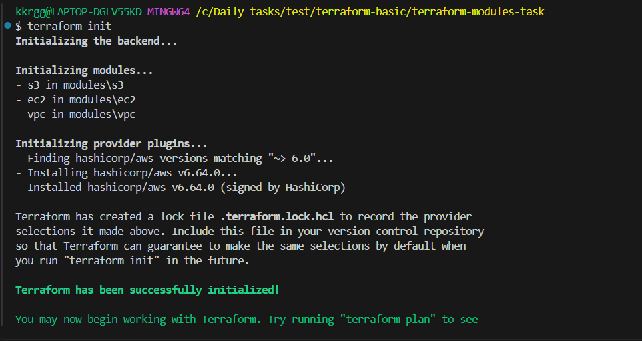
Then:
terraform validate
Expected:
Success! The configuration is valid.
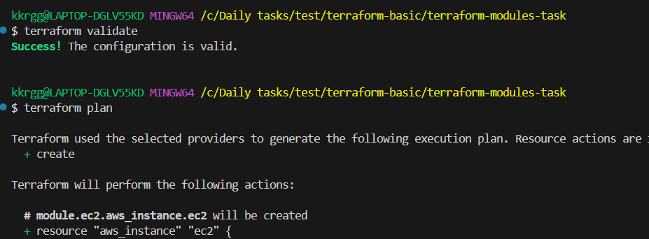

10. Run Terraform plan
terraform plan
You should see resources to be created.
Approximately:
Plan: 8 to add, 0 to change, 0 to destroy.
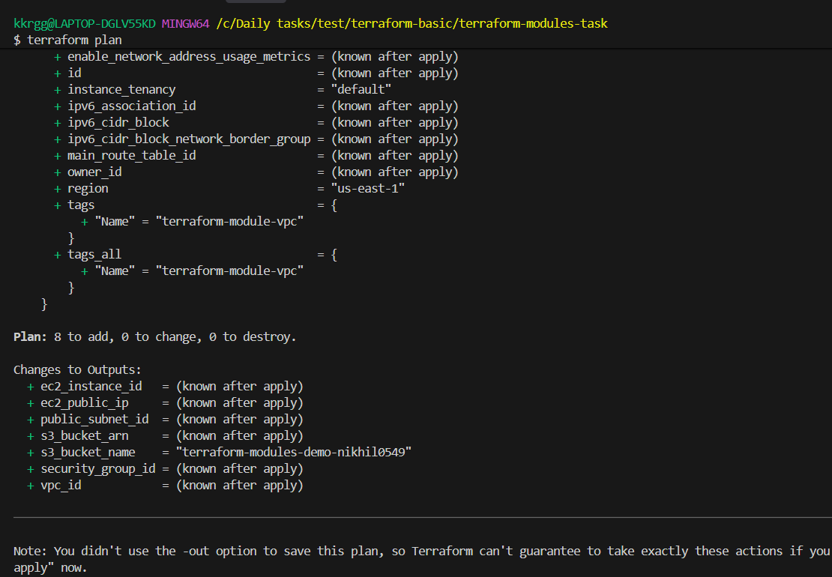

11. Apply
terraform apply
Terraform will ask:
Do you want to perform these actions?
Terraform will perform the actions described above.

Enter a value:
Enter:
Yes
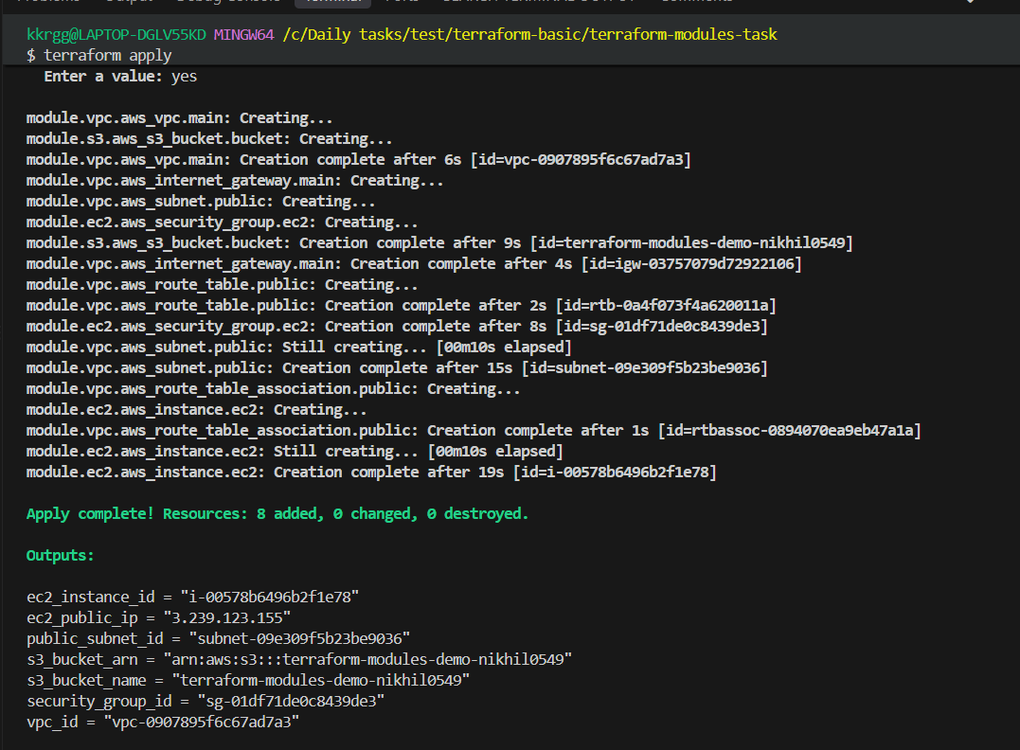

12. Verify outputs
After successful creation:
terraform output
You should get something similar to:
ec2_instance_id = "i-xxxxxxxxxxxxxxxxx"

ec2_public_ip = "54.xx.xx.xx"

public_subnet_id = "subnet-xxxxxxxxxxxxxxxxx"

s3_bucket_arn = "arn:aws:s3:::terraform-modules-0549-demo"

s3_bucket_name = "terraform-modules-0549-demo"

security_group_id = "sg-xxxxxxxxxxxxxxxxx"

vpc_id = "vpc-xxxxxxxxxxxxxxxxx"

13. Verify in AWS
Check:

VPC
AWS Console → VPC → Your VPCs
You should see:
terraform-module-vpc
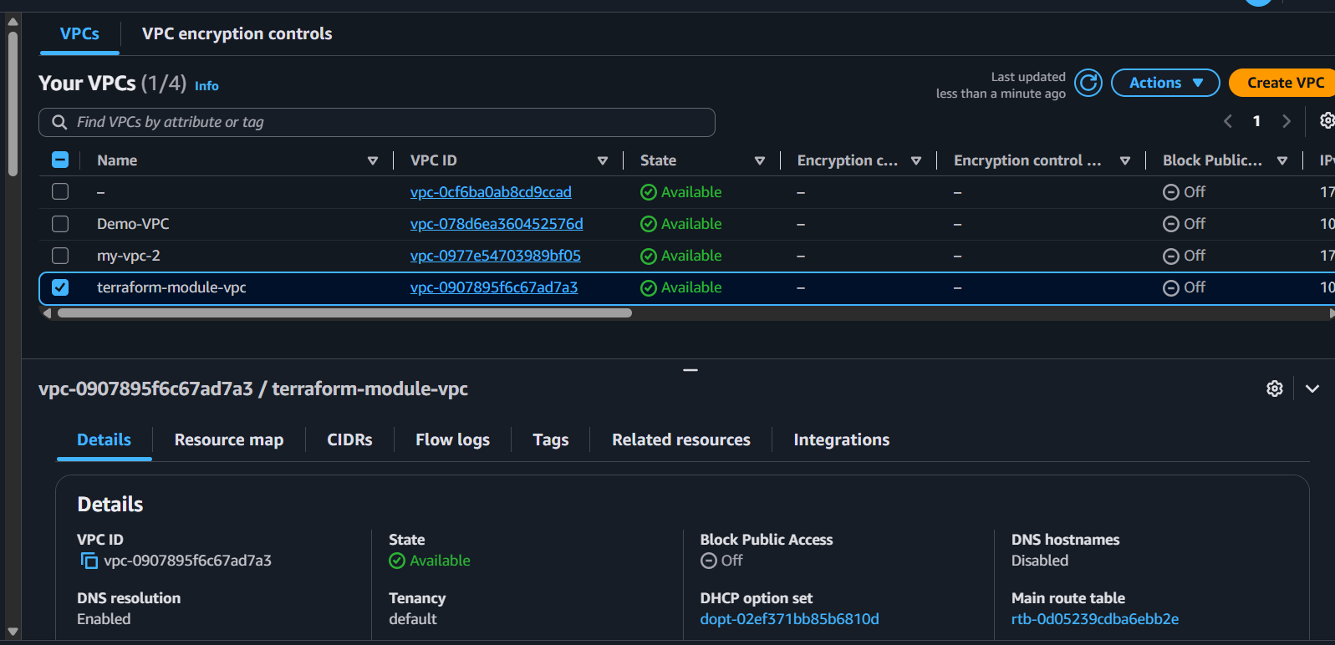

Subnet
terraform-module-vpc-public-subnet
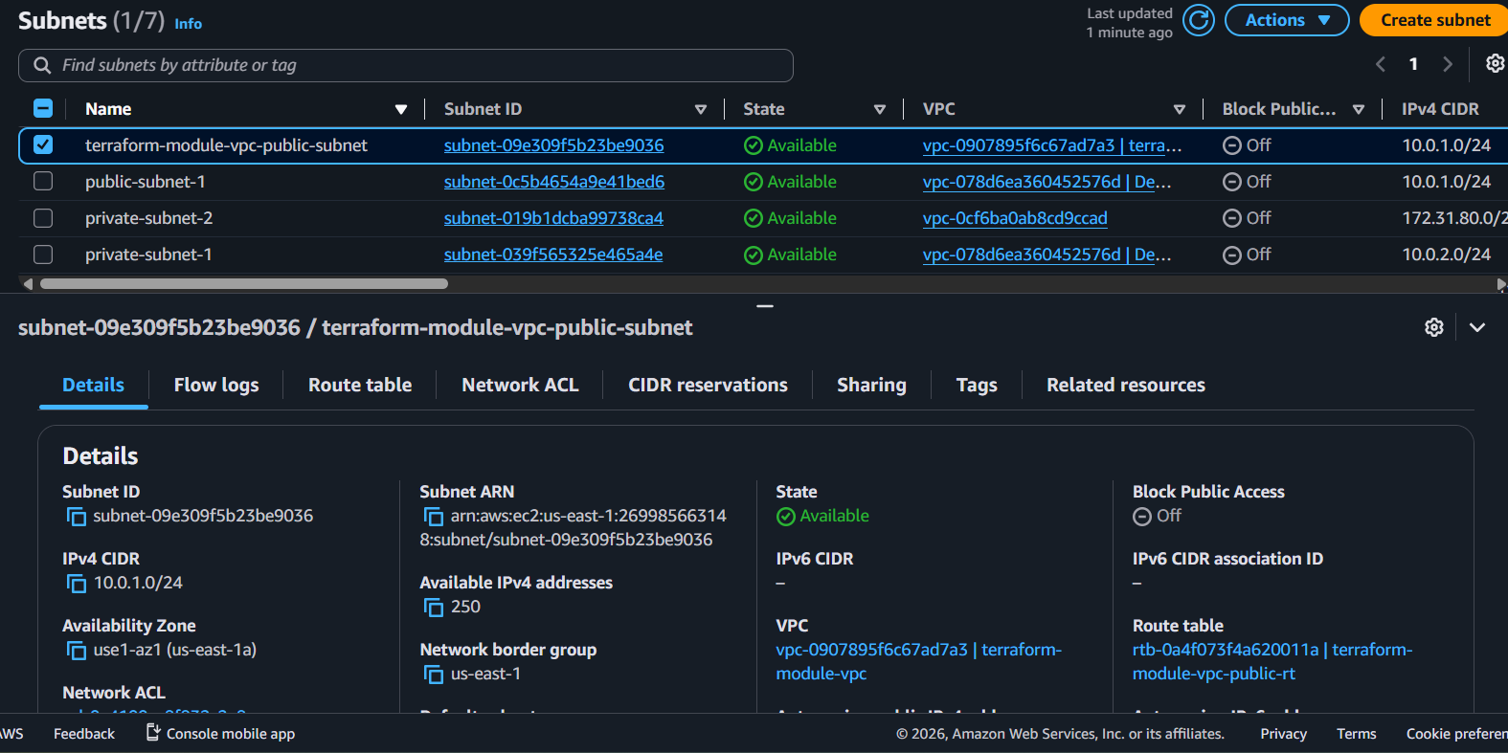

EC2
EC2 → Instances:
terraform-module-ec2
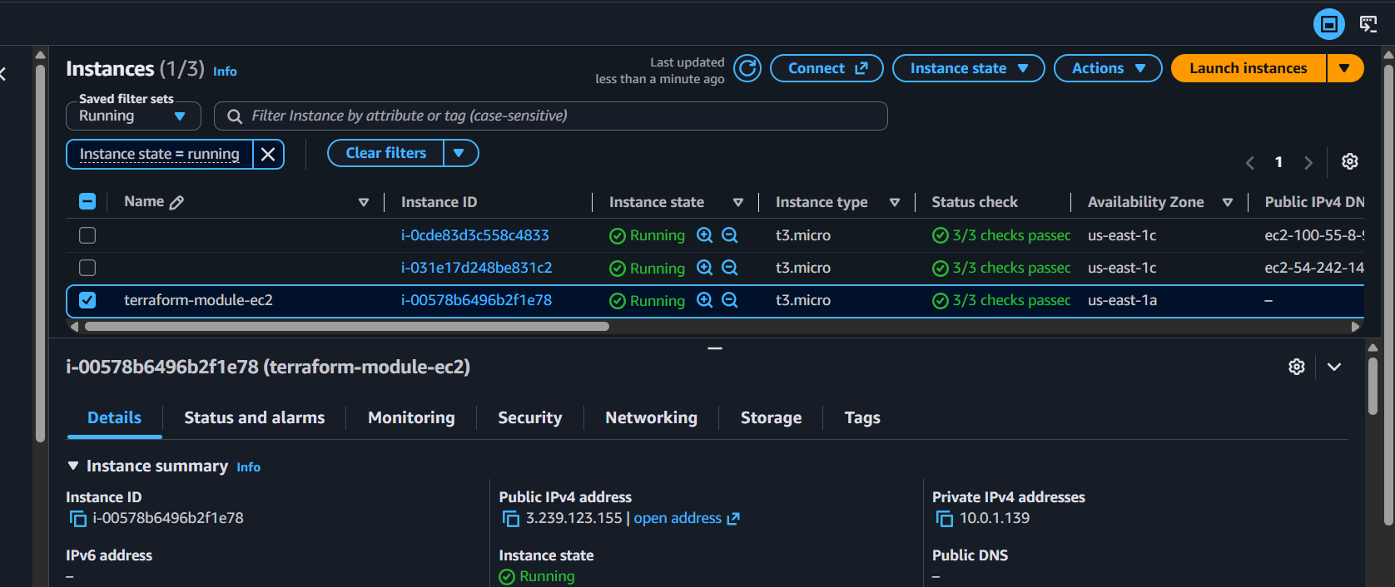

S3
S3 → Buckets:
terraform-modules-0549-demo
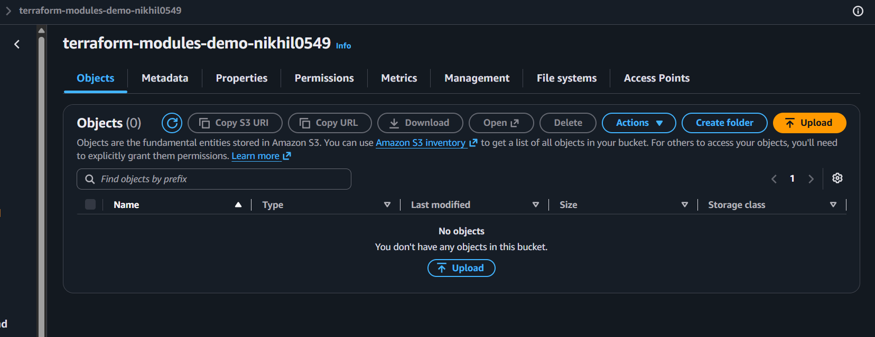

14. Understand what we built
The root module is the main controller:
main.tf
│
├── module.vpc
│ │
│ ├── VPC
│ ├── Subnet
│ ├── Internet Gateway
│ └── Route Table
│
├── module.ec2
│ │
│ ├── Security Group
│ └── EC2
│
└── module.s3
│
└── S3 Bucket
The important module dependency is:
VPC Module
│
│ vpc_id
│ subnet_id
↓
EC2 Module
So this:
subnet_id = module.vpc.public_subnet_id
means:
Take the public_subnet_id output from the VPC module and pass it to the EC2 module.

15. Why modules?
Without modules, everything could be in one large main.tf.
With modules:
modules/
├── vpc/
├── ec2/
└── s3/
we can reuse them.
For example, later we could have:
module "dev_vpc" {
source = "./modules/vpc"
...
}

module "prod_vpc" {
source = "./modules/vpc"
...
}
The same VPC module can be reused with different values.

3. Provision EC2 for 3 different environments (Dev, Staging, and Prod) using Terraform workspaces.

Objective
Use one Terraform configuration and three workspaces:
dev
staging
prod
Each workspace will create an EC2 instance with environment-specific values.

Architecture
Terraform Configuration
│
┌─────────────┼─────────────┐
│ │ │
dev staging prod
│ │ │
EC2-Dev EC2-Staging EC2-Prod
t3.micro t3.micro t3.small
The important concept is:
One Terraform configuration + multiple workspaces = separate Terraform state for each environment.

1. Create the project
mkdir terraform-workspaces
cd terraform-workspaces
Create:
terraform-workspaces/
├── main.tf
├── variables.tf
├── terraform.tfvars
└── outputs.tf
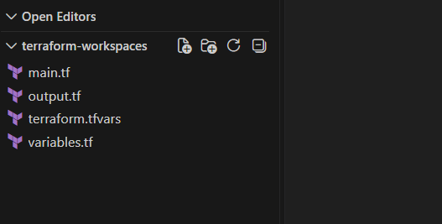

2. Create main.tf
terraform {
required_providers {
aws = {
source = "hashicorp/aws"
version = "~> 6.0"
}
}
}

provider "aws" {
region = var.aws_region
}

resource "aws_instance" "app" {
ami = var.ami_id
instance_type = var.instance_type

tags = {
Name = "${var.environment}-server"
Environment = var.environment
}
}

What is happening?
This part:
Name = "${var.environment}-server"
will produce different names depending on the workspace:
dev-server
staging-server
prod-server

3. Create variables.tf
variable "aws_region" {
type = string
}

variable "ami_id" {
type = string
}

variable "instance_type" {
type = string
}

variable "environment" {
type = string
}

4. Create terraform.tfvars
aws_region = "us-east-1"

ami_id = "ami-xxxxxxxxxxxxxxxxx"

instance_type = "t3.micro"

environment = "default"
Replace:
ami-xxxxxxxxxxxxxxxxx

with a valid Amazon Linux AMI ID available in us-east-1.
ami-0b6d9d3d33ba97d99

However, there is an important point here: we don't actually want to manually change terraform.tfvars every time we switch environments.
We'll use workspace-based conditional values next.

5. Modify main.tf for different environments
Replace main.tf with this complete code:
terraform {
required_providers {
aws = {
source = "hashicorp/aws"
version = "~> 6.0"
}
}
}

provider "aws" {
region = var.aws_region
}

locals {
environment = terraform.workspace

instance_types = {
dev = "t3.micro"
staging = "t3.micro"
prod = "t3.small"
}
}

resource "aws_instance" "app" {
ami = var.ami_id
instance_type = local.instance_types[terraform.workspace]

tags = {
Name = "${local.environment}-server"
Environment = local.environment
}
}
Now Terraform automatically uses the current workspace:
terraform.workspace
For example:
workspace = dev
then:
terraform.workspace = "dev"
and Terraform selects:
t3.micro
For:
workspace = prod
Terraform selects:
t3.small

6. Simplify variables.tf
Since environment now comes from the workspace, we don't need it as a variable.
Use:
variable "aws_region" {
type = string
}

variable "ami_id" {
type = string
}

7. Update terraform.tfvars
aws_region = "us-east-1"

ami_id = "ami-xxxxxxxxxxxxxxxxx"
Again, replace the AMI ID with your valid us-east-1 Amazon Linux AMI.

8. Create outputs.tf
output "instance_id" {
value = aws_instance.app.id
}

output "public_ip" {
value = aws_instance.app.public_ip
}

output "instance_type" {
value = aws_instance.app.instance_type
}

output "environment" {
value = terraform.workspace
}

9. Initialize Terraform
Run:
terraform init
Expected:
Initializing the backend...
Initializing provider plugins...

Terraform has been successfully initialized!
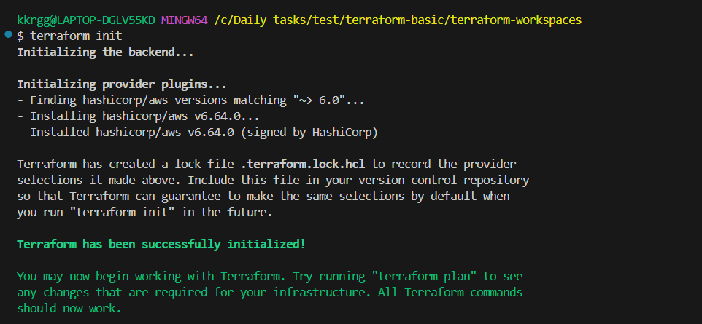
Then:
terraform validate
Expected:
Success! The configuration is valid.
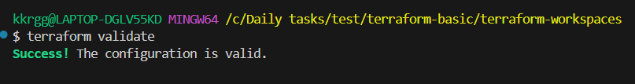

10. Check current workspace
Run:
terraform workspace show
Initially you will normally see:
default
List all workspaces:
terraform workspace list
Output:
* default
The * means the current workspace.

11. Create Dev workspace
Run:
terraform workspace new dev
Expected:
Created and switched to workspace "dev"!
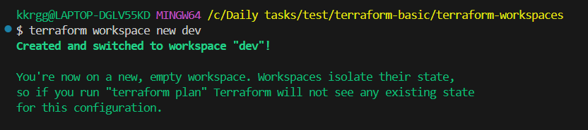
Check:
terraform workspace show
Output:
Dev
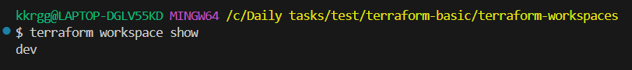

12. Provision Dev EC2
Run:
terraform plan
You should see:
Plan: 1 to add, 0 to change, 0 to destroy.
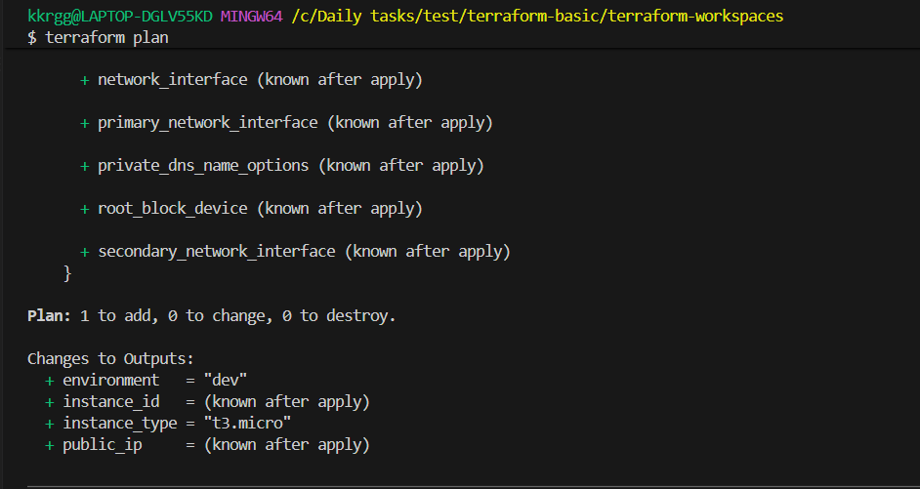
Then:
terraform apply
Enter:
yes
Terraform creates:
dev-server
with:
t3.micro
Check:
terraform output
You should get something like:
environment = "dev"
instance_id = "i-xxxxxxxxxxxxxxxxx"
instance_type = "t3.micro"
public_ip = "xx.xx.xx.xx"

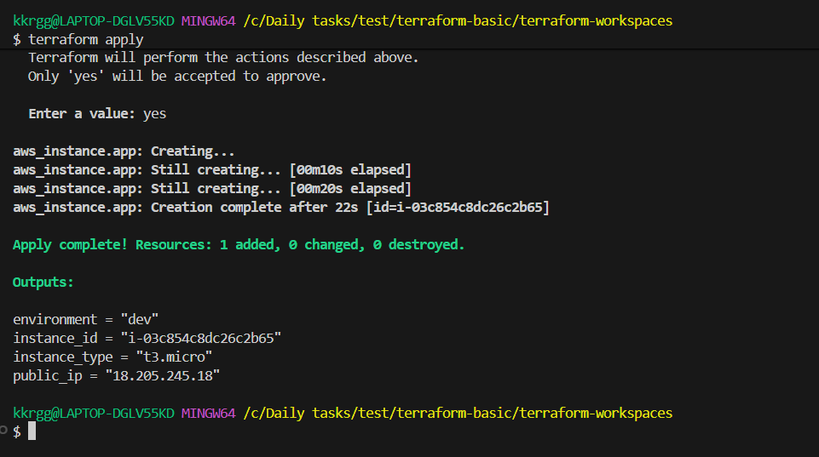

13. Create Staging workspace
Now don't modify the Terraform files.
Run:
terraform workspace new staging
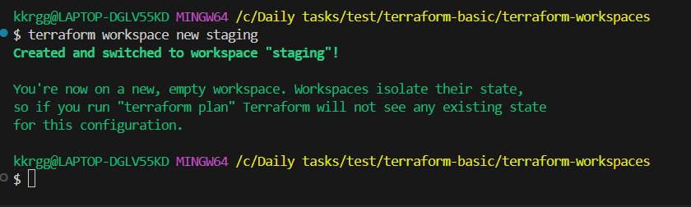
Check:
terraform workspace show
Output:
Staging
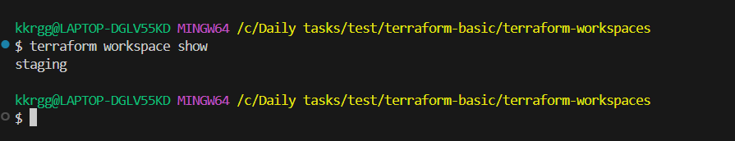
Now:
terraform plan
Terraform sees that staging has its own state.
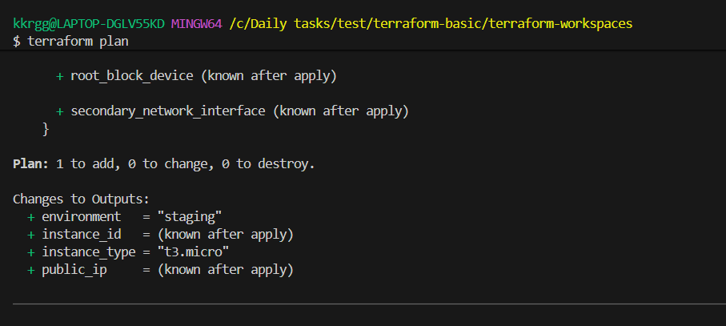
Then:
terraform apply
Enter:
yes
Terraform creates:
staging-server
with:
t3.micro
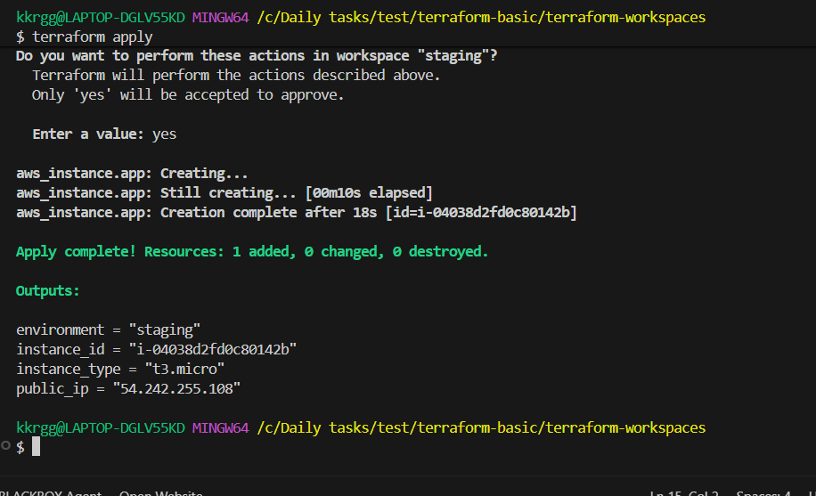

14. Create Prod workspace
Run:
terraform workspace new prod
Check:
terraform workspace show
Output:
Prod
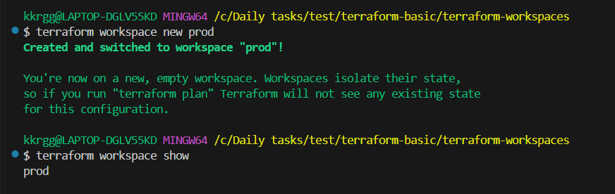

Run:
terraform plan
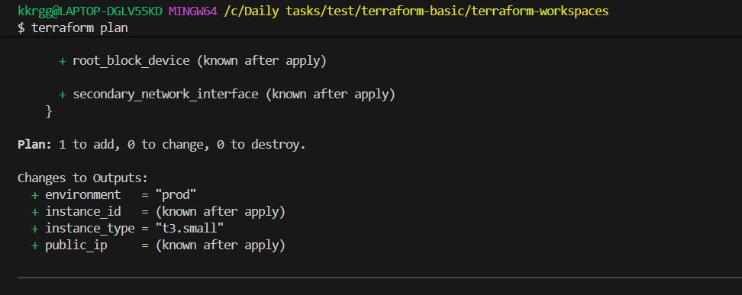
Then:
terraform apply
Enter:
yes
Terraform creates:
prod-server
with:
t3.small
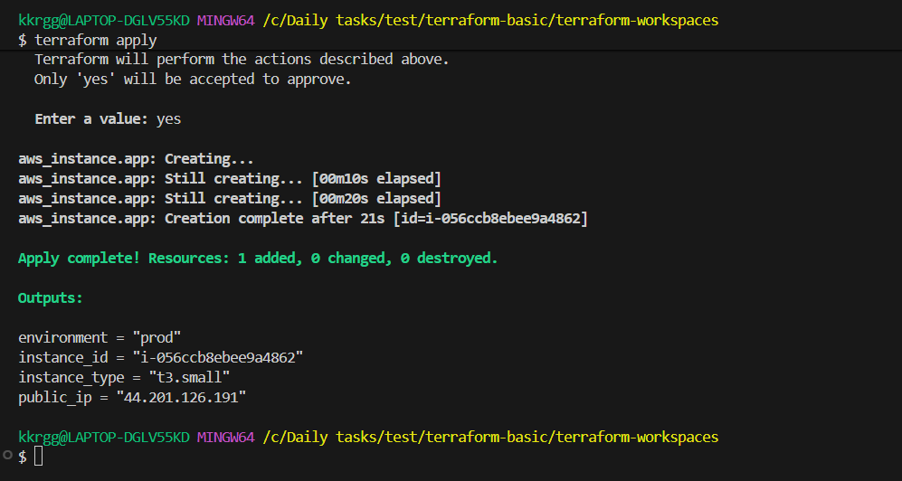

15. Check all workspaces
Run:
terraform workspace list
You should now see:
default
dev
staging
* prod
The * indicates the current workspace.
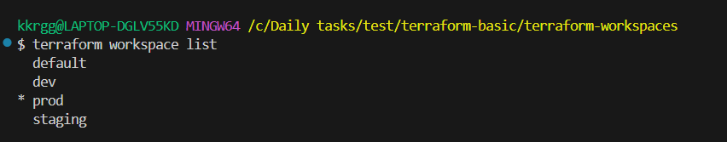

16. Switch between environments
To switch to Dev:
terraform workspace select dev
Check:
terraform workspace show
Output:
dev
Switch to Staging:
terraform workspace select staging
Switch to Prod:
terraform workspace select prod
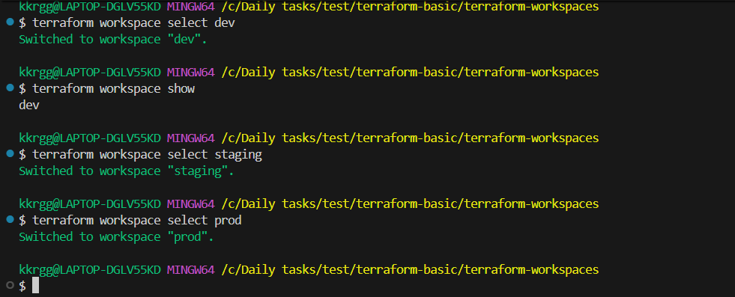

17. Understand the important concept
Suppose you're currently in:
dev
When you run:
terraform plan
Terraform compares your configuration against the Dev workspace state.
When you switch:
terraform workspace select prod
Terraform uses the Prod workspace state.
So:
Same Terraform Code
│
┌──────────────┼──────────────┐
│ │ │
dev staging prod
│ │ │
State State State
│ │ │
EC2 Dev EC2 Staging EC2 Prod
This is the main purpose of workspaces.

18. Where is the state?
Conceptually:
terraform.tfstate
for the default workspace, and additional workspace state is stored separately under Terraform's workspace state structure.
You can inspect the current state with:
terraform state list
For Dev:
terraform workspace select dev
terraform state list
You should see:
aws_instance.app
Then switch to Prod:
terraform workspace select prod
terraform state list
You will also see:
aws_instance.app
But it refers to the Prod EC2, because the state belongs to the Prod workspace.

19. Verify all three EC2 instances
In the AWS EC2 console, you should have:
Environment | Instance Name | Type
Dev | dev-server | t3.micro
Staging | staging-server | t3.micro
Prod | prod-server | t3.small
So we used one aws_instance resource definition:
resource "aws_instance" "app"
but created three separate instances because of the three workspaces.
